
Company
Logotype

Cone Beam Computed Tomography- Report



Porur Dental X-rays & CBCT

Patient Name : Mrs. Abirami | Date of Report : 28.10.2025
Age/ Gender : 33 years/ Female | Region of Interest : CBCT Sectional Mandible
Referring doctor: Dr. Selva Ganesh | Indication : Implant assessment
Clinical Notes: Nil
PATIENT INFORMATION

CBCT- Sectional Mandible provided
CBCT – IMAGE DETAILS

RADIOGRAPHIC INTERPRETATION

- Partial loss of crown in relation to 46, and presence of hyperdense restorative material in relation to the pulp canals, extending upto the apical third of 46 is evident.
- Horizontally positioned tooth : 48.
- The mandibular alveolar ridge is present with normal trabecular pattern.

 | 46 region
Sub-Crestal (in mm) | 8.37
Mid- Crestal (in mm) | 8.10
Distance between alveolar ridge and the inferior alveolar nerve canal (in mm) | 14.14
Distance between alveolar ridge and the inferior border of mandible (in mm) | 21.47

IMPLANT ASSESSMENT

RADIOGRAPHIC IMPRESSION

- Root canal treated tooth: 46
- Horizontal impaction in relation to 48.

Kindly correlate with clinical findings


IMAGES FOR REFERENCE

RECONSTRUCTED PANORAMIC VIEW

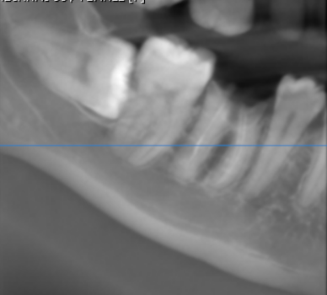

3-DIMENSIONAL VIEW

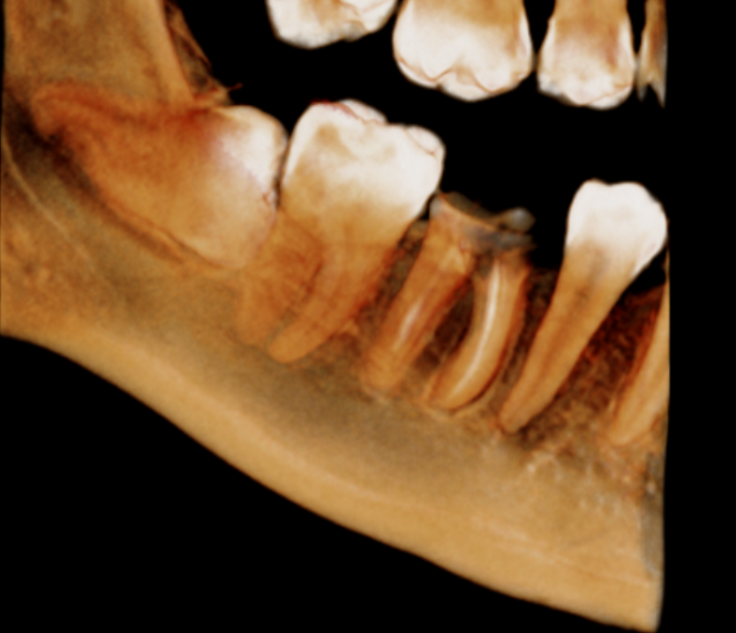

CROSS SECTIONAL VIEW

46 region | 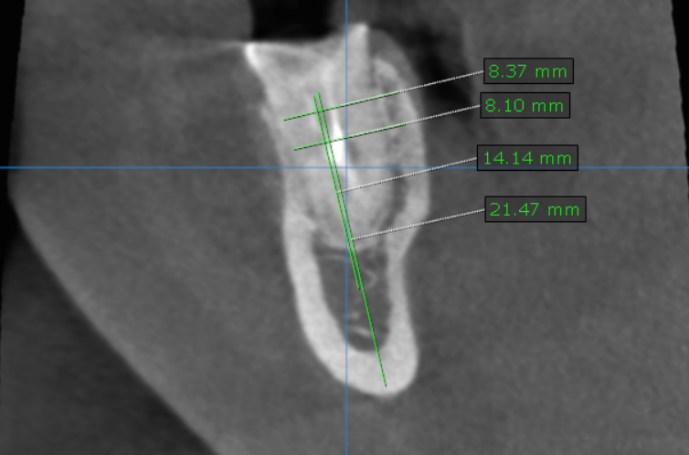

**** End of report ****

